RAM VERIFICATION
Design Specification & Coverage Summary Report
Single-Port RAM (8-bit x 32)

Prepared by: Debangshu Kundu
Employee ID: 6890
Date: 06 July 2026

1. Introduction
This report summarizes the design specification of the Single-Port RAM block and presents the functional verification coverage results collected from the testbench. The goal is to explain, in simple terms, what the RAM is supposed to do, how the testbench checks it, and how thoroughly it has been tested.
The RAM discussed here is a single-port memory: it is 8 bits wide and has 32 addressable locations (addresses 0 to 31). It runs at an operating frequency of 50 MHz.
This document is organised so that a reader with no prior context can follow it end to end: it starts with what the RAM does, moves through how each pin and operation behaves, then explains how the verification environment is built, and finally reports how completely that environment has exercised the design.

1.1 Purpose of This Report
- Explain the RAM's functional specification in plain, non-jargon language.
- Describe the verification testbench and the role each component plays.
- Present the functional coverage results in an easy-to-read tabular format.
- Provide a placeholder section for future updates as the project progresses.

2. Design Overview & Functional Description
In plain words, this block is a small memory cupboard with 32 shelves (addresses), and each shelf can hold one 8-bit value. Only one operation — a read or a write — can happen at a time; the RAM does not support doing both together.

2.1 Key Behaviour Rules
- Reset behaviour: When reset is asserted (active low, so reset = 0), the RAM goes to an idle state. All inputs are treated as zero, except data_in, which goes to high impedance (Z). The output data_out also goes to Z.
- Write with invalid address: If a write is attempted to an address outside the valid range, the RAM simply ignores the operation — nothing is written.
- Read with invalid address: If a read is attempted from an invalid address, the RAM returns Z (high impedance) on data_out.
- No concurrent access: The RAM cannot perform a read and a write operation at the same time; only one is active per cycle.

2.2 Block Diagram
The RAM block has the following interface, shown conceptually below:
- Inputs: clk, reset, data_in, address, write_enb, read_enb
- Output: data_out
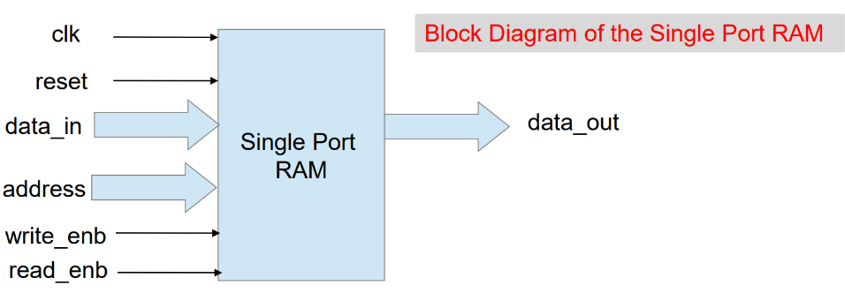
Figure:-Single Port Ram.
Bugs:-
- There are no design bugs.
- In test bench, the interfaces are not instantiated in some parts.
- In test module,while calling the constructor,all the interfaces were not mentioned.
- In top module also some interfaces were not present.(only driver and monitor interfaces are present).

3. Pin Description
The table below lists every pin of the RAM, its direction, its width in bits, and what it is used for.
Pin Name | Direction | Width (bits) | Functionality
clk | Input | 1 | Clock signal to the RAM
reset | Input | 1 | Active-low reset signal, used to initialize the RAM
write_enb | Input | 1 | Active-high signal that enables a write operation
read_enb | Input | 1 | Active-high signal that enables a read operation
data_in | Input | 8 | Data value to be written into the RAM
address | Input | 5 | Selects the memory location, from 0 to 31
data_out | Output | 8 | Data value read out from the RAM

4. Memory Write Operation
Writing to the RAM happens on the positive (rising) edge of the clock, and only when the conditions below are true.
- When reset = 0 (reset is active): data_in stays at high impedance (Z) and address is treated as zero. The RAM does not write anything in this state.
- When reset = 1, write_enb = 1 and read_enb = 0: the value on data_in is written into the memory location pointed to by address, on the next rising clock edge.
In simple terms: think of write_enb as a 'go-ahead to write' switch. As long as reset is released and only the write switch is on (not the read switch), whatever value is sitting on data_in gets copied onto the shelf identified by address.

4.1 Points to Remember
- The write only takes effect on a rising clock edge — nothing changes in between clock edges.
- If the address supplied during a write is invalid (outside 0–31), the RAM simply does nothing; no memory location is altered.
- Since read and write cannot happen together, write_enb and read_enb should not both be high at the same time.

5. Memory Read Operation
Reading from the RAM also happens on the rising edge of the clock, under a different set of conditions.
- When reset = 0 (reset is active): data_out stays at high impedance (Z) and address is treated as zero.
- When reset = 1, write_enb = 0 and read_enb = 1: the value stored in memory at the location pointed to by address is placed onto data_out.
In simple terms: read_enb is the 'go-ahead to read' switch. When it is the only switch turned on, the RAM fetches whatever value is stored on the shelf named by address and presents it on data_out.

5.1 Points to Remember
- Like the write operation, the read is synchronous — it is driven by the rising edge of clk.
- If the address supplied during a read is invalid, data_out becomes Z rather than showing stale or incorrect data.
- data_out holds its value until the next valid read changes it, since there is no continuous/combinational read path.

6. Testbench Architecture
The RAM is verified using a layered testbench environment. The diagram below shows all the components and how data flows between them.
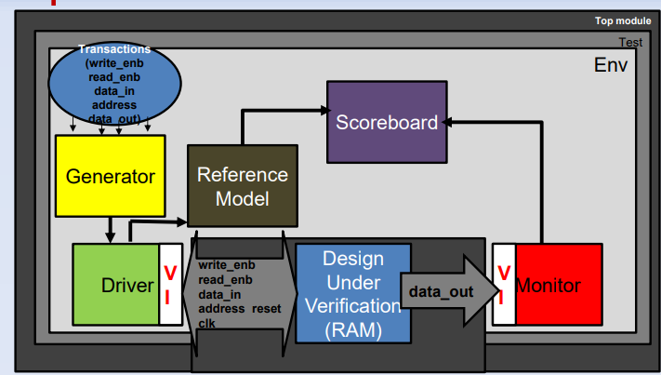
Figure: Testbench Block Diagram

6.1 What Each Component Does
- Test: The starting point of a test. It configures the environment and kicks off the simulation with a particular test scenario.
- Env (Environment): The container that holds and connects all the reusable verification components together — generator, driver, reference model, monitor, and scoreboard.
- Generator: Creates random or directed transactions — combinations of write_enb, read_enb, data_in, address, and expected data_out — that represent the stimulus to be applied to the RAM.
- Driver: Takes each transaction produced by the generator and converts it into actual pin-level signal wiggles (write_enb, read_enb, data_in, address, reset, clk) that are applied to the DUV.
- Reference Model: A software 'golden' copy of the RAM's expected behaviour. It predicts what the RAM should do for each transaction, independent of the actual hardware design.
- DUV (Design Under Verification): This is the actual RAM design (the RTL) being tested.
- Monitor: Watches the DUV's data_out pin (and other signals) passively, without interfering, and packages what it observes into transactions for checking.
- Scoreboard: Compares the prediction from the Reference Model against what the Monitor actually observed from the DUV. If they match, the test passes for that transaction; if not, a mismatch is flagged.
In short: the Generator creates test cases, the Driver applies them to the RAM, the Reference Model predicts the correct answer, the Monitor observes the RAM's real answer, and the Scoreboard checks that the two agree.

7. Functional Coverage Report
Functional coverage measures how thoroughly the test scenarios have exercised the design's behaviour. The results below were captured from the Questa coverage report (covsummary.html).
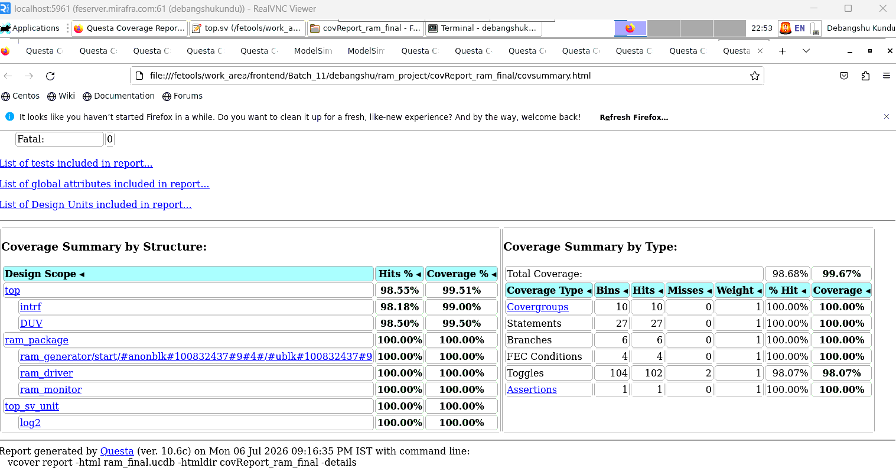

7.1 Coverage Summary by Type
Coverage Type | Bins | Hits | Misses | Weight | % Hit | Coverage
Covergroups | 10 | 10 | 0 | 1 | 100.00% | 100.00%
Statements | 27 | 27 | 0 | 1 | 100.00% | 100.00%
Branches | 6 | 6 | 0 | 1 | 100.00% | 100.00%
FEC Conditions | 4 | 4 | 0 | 1 | 100.00% | 100.00%
Toggles | 104 | 102 | 2 | 1 | 98.07% | 98.07%
Assertions | 1 | 1 | 0 | 1 | 100.00% | 100.00%
Overall Total Coverage: 98.68% Hits, 99.67% Coverage.

7.2 Coverage Summary by Structure
Design Scope | Hits % | Coverage %
top | 98.55% | 99.51%
top.intrf | 98.18% | 99.00%
top.DUV | 98.50% | 99.50%
ram_package | 100.00% | 100.00%
ram_generator | 100.00% | 100.00%
ram_driver | 100.00% | 100.00%
ram_monitor | 100.00% | 100.00%
top_sv_unit | 100.00% | 100.00%
log2 | 100.00% | 100.00%

7.3 Observations
- All covergroups, statements, branches, FEC conditions and the single assertion reached 100% coverage.
- Toggle coverage is close to complete at 98.07%, with only 2 out of 104 toggle bins left un-hit — these likely correspond to a small number of signal transitions (0→1 or 1→0) that were not exercised.
- The DUV itself reached 99.50% coverage, and the overall design (top) reached 99.51%, indicating the verification environment has tested the RAM very thoroughly.
- No fatal errors were reported during the run.

8. Summary & Conclusion
The Single-Port RAM is a simple but strict memory block: it writes a byte to a chosen address when told to, reads a byte from a chosen address when told to, never does both at once, and cleanly goes to a high-impedance idle state on reset. Invalid addresses are handled safely — writes are ignored and reads return Z, rather than corrupting data or producing unknown behaviour.
The layered UVM-style testbench (Generator, Driver, Reference Model, DUV, Monitor and Scoreboard) automatically generates test scenarios, applies them to the design, predicts the correct behaviour, observes the actual behaviour, and checks that the two match — removing the need for manual, one-off checking.
The coverage results confirm that this verification effort has been thorough: every covergroup, statement, branch, condition and assertion reached 100% coverage, and toggle coverage stands at 98.07%, with only 2 of 104 toggle bins remaining. Overall, the design has reached 99.67% total coverage with no fatal errors, indicating the RAM is well-verified and ready for the next stage of sign-off, pending closure of the remaining toggle bins.

